**SQL JOIN Queries Quiz**

**Question 1**

Which of the JOIN operations do not preserve non matched tuples?

* Inner join

**Question 2**

Consider the following ORDER_ITEM and CUSTOMER_ORDER tables:

|  |  |
| --- | --- |
| CUSTOMER_ORDER | ORDER_ITEM |
|  |  |

Which of the following statement returns the following output?

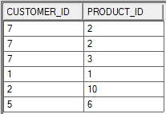

* *SELECT CUSTOMER_ID, PRODUCT_ID*

*FROM ORDER_ITEM NATURAL JOIN CUSTOMER_ORDER;*

**Question 3**

Consider the following ORDER_ITEM and CUSTOMER_ORDER tables:

|  |  |
| --- | --- |
| CUSTOMER_ORDER | ORDER_ITEM |
|  |  |

Which of the following statement returns the following output?

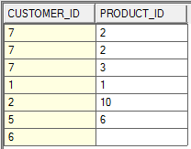

* *SELECT CUSTOMER_ID, PRODUCT_ID*

*FROM ORDER_ITEM NATURAL RIGHT JOIN CUSTOMER_ORDER;*

**Question 4**

Consider the following ORDER_ITEM and CUSTOMER_ORDER tables:

|  |  |
| --- | --- |
| CUSTOMER_ORDER | ORDER_ITEM |
|  |  |

Which of the following result sets was produced by this SQL query?

*SELECT CUSTOMER_ID, AVG(quantity) AS "Average Quantity"*

*FROM ORDER_ITEM NATURAL RIGHT JOIN CUSTOMER_ORDER*

*GROUP BY CUSTOMER_ID;*

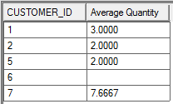

**Question 5**

Consider the following ORDER_ITEM and CUSTOMER_ORDER tables:

|  |  |
| --- | --- |
| CUSTOMER_ORDER | ORDER_ITEM |
|  |  |

Which of the following SQL statements produced this result?

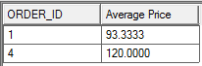

* *SELECT ORDER_ID, AVG(UNIT_PRICE) AS "Average Price"*

*FROM ORDER_ITEM NATURAL JOIN CUSTOMER_ORDER*

*GROUP BY ORDER_ID*

*having AVG(UNIT_PRICE) > 50;*

**Question 6**

Consider the following ORDER_ITEM and CUSTOMER_ORDER tables:

|  |  |
| --- | --- |
| CUSTOMER_ORDER | ORDER_ITEM |
|  |  |

Which of the following statements would calculate the order total of all orders?

* *SELECT CUSTOMER_ID, ORDER_ID, SUM(UNIT_PRICE*QUANTITY) AS TOTAL*

*FROM ORDER_ITEM NATURAL JOIN CUSTOMER_ORDER*

*GROUP BY ORDER_ID, CUSTOMER_ID;*

**Question 7**

Which of the following statements is **false**?

* Views store the data that is not stored in any of the underlying tables.

**Question 8**

What does the NATURAL JOIN command do?

* It joins the table using the columns with identical names.